**Faculty of engineering - Shoubra**

**Benha University**

# Research Article

In fulfillment of the requirements of

|  |  |
| --- | --- |
| **Department** | Engineering Mathematics and Physics |
| **Division** | ---------------------- |
| **Academic Year** | 2019-2020Preparatory |
| **Course name** | Computer |
| **Course code** | ECE001 |

## Title: -

Artificial Intelligence

By:

|  |  |  |  |
| --- | --- | --- | --- |
|  | Name | Edu mail | B.N |
| 1 | حسام مصطفى لبيب محمد | Hossam195322@feng.bu.edu.eg | 290 |

**Approved by:**

|  |  |
| --- | --- |
| Examiners committee | Signature |
| Dr.Ahmed Bayoumi |  |
| Dr.Shady Elmashad |  |
| Dr.Abdelhamid Attaby |  |

**research**

In this research I talk about Artificial Intelligence I start by definition it whish mean the ability of a digital computer or computer-controlled robot to perform tasks commonly associated with intelligent beings. Then I talk about its history then its application and its benefits and there are some codes: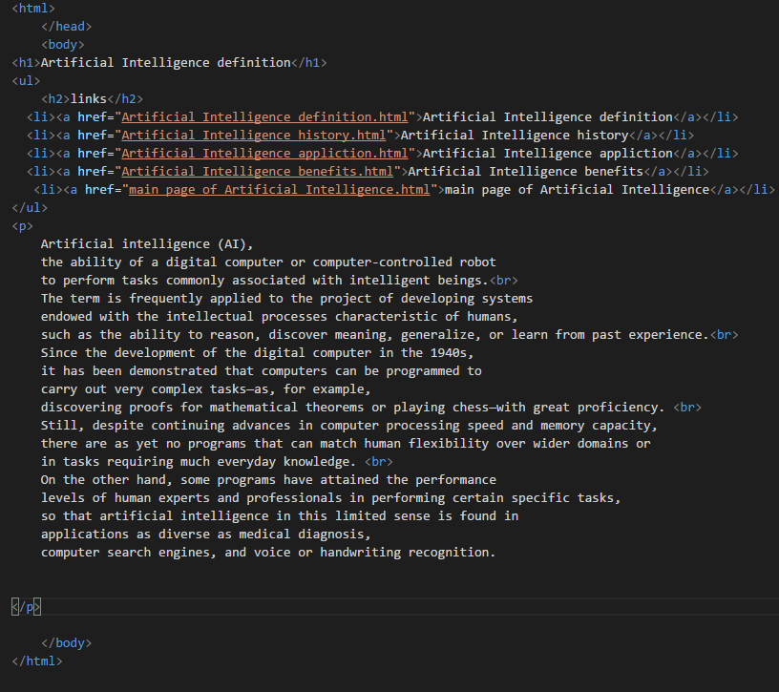

And there is an image:

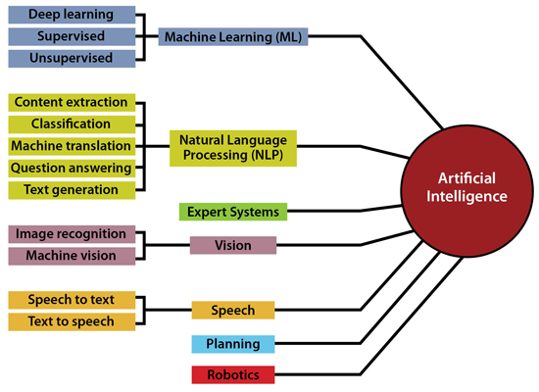

My link in GitHub

<https://github.com/hosamazab/ece001>

this is the link of my web site that I did

<https://hosamazab.github.io/ece001/>

# References

<https://www.sas.com/en_us/insights/analytics/what-is-artificial-intelligence.html>

<https://www.britannica.com/technology/artificial-intelligence/Reasoning>

<https://www.datamation.com/artificial-intelligence/examples-of-artificial-intelligence.html>

<https://www.educba.com/advantages-of-artificial-intelligence/>